Ethics and AI Laboratory

INDEX

|  |  |
| --- | --- |
| 1 | Two variable linear regression model |
| 2 | 3D linear Regression Model |
| 3 | Perceptron with and without bias using UCI Repository |
| 4 | Case study on ontology where ethics is at stake |
| 5 | Regression model without a bias and with bias |
| 6 | Case study of ethical initiatives in healthcare |
| 7 | Case study of ethical initiatives in autonomous vehicles |
| 8 | Case study of ethical initiatives in defense |

Program 1

Two variable linear regression model

Aim :

To demonstrate simple linear regression using randomly generated data to establish a linear relationship between two variables.

Algorithm :

STEP - 1 : Generate random data points for ‘x’ and create corresponding ‘y’ values.

STEP - 2 : Create a dataframe from the generated data.

STEP - 3 : Check and display the shape, head and data types of the dataframe.

STEP - 4 : Check for missing values in the dataframe.

STEP - 5 : Calculate the correlation matrix and create a scatter plot of x and y.

STEP - 6 : Visualize Fit a linear regression model, make predictions, and plot the results.

Program :

import pandas as pd

import numpy as np

import matplotlib.pyplot as plt

from sklearn import linear_model

# Generate random data

np.random.seed(0)

x = np.random.rand(100)

y = 3 * x + np.random.rand(100)

# Create a DataFrame from the data

df = pd.DataFrame({'x': x, 'y': y})

# Check the shape of the data

print(df.shape)

# Print the head of the data

print(df.head())

# Check the data types of the features

print(df.dtypes)

# Check for missing values

print(df.isnull().sum())

# Calculate the correlation between the features

corr = df.corr()

print(corr)

# Plot the correlation matrix

plt.matshow(corr)

plt.colorbar()

plt.title('Correlation Matrix')

plt.show()

# Create a scatter plot of the two variables

plt.scatter(df['x'], df['y'])

plt.xlabel('x')

plt.ylabel('y')

plt.title('Scatter Plot of x and y')

plt.show()

# Fit a linear regression model

model = linear_model.LinearRegression()

model.fit(df[['x']], df['y'])

# Print the coefficients of the model

print('Coefficients:', model.coef_)

# Print the intercept of the model

print('Intercept:', model.intercept_)

# Make predictions

predictions = model.predict(df[['x']])

# Plot the predictions

plt.scatter(df['x'], df['y'])

plt.plot(df['x'], predictions, color='red')

plt.xlabel('x')

plt.ylabel('y')

plt.title('Predictions from Linear Regression Model')

plt.show()

Output :

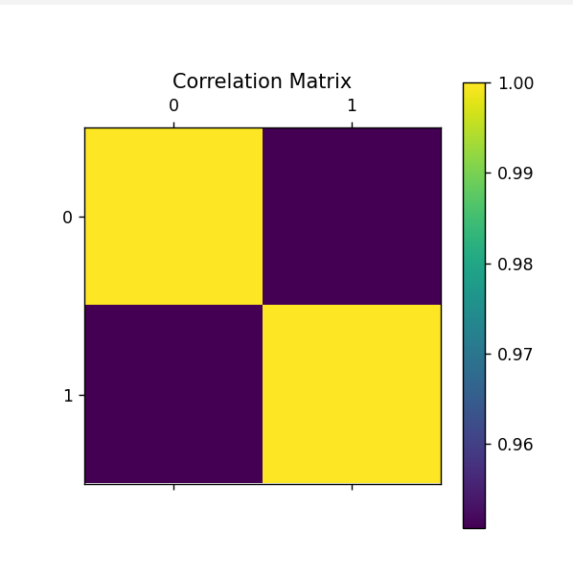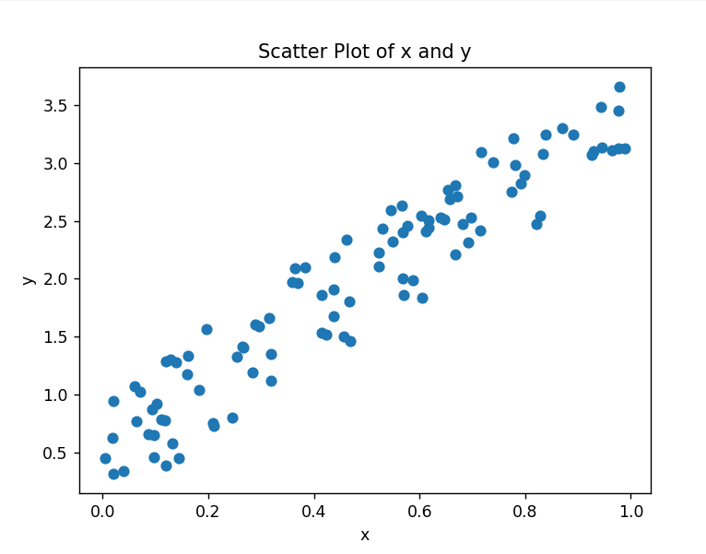

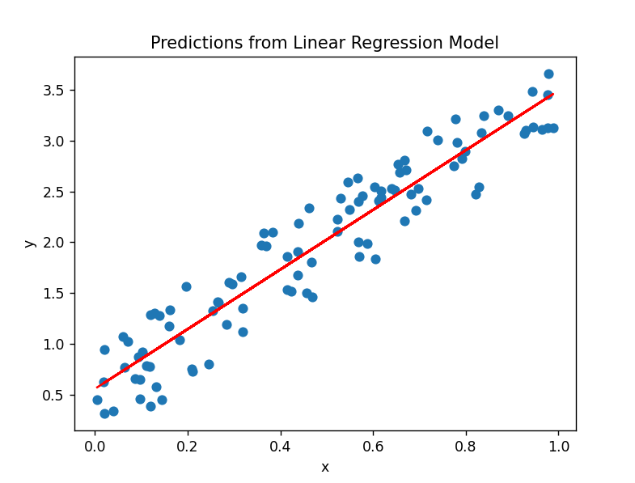

Result :

Linear regression using randomly generated data to establish a linear relationship between two variables was demonstrated and executed successfully.

Program 2

3D linear Regression Model

Aim :

To generate a synthetic data-set and performs 3D linear regression visualization using matplotlib.

Algorithm :

STEP - 1 : Generate a synthetic dataset with 200 samples.

STEP - 2 : Define a 3D plot using matplotlib.

STEP - 3 : Scatter plot the dataset points in 3D space.

STEP - 4 : Set up the regression equation with random coefficients.

STEP - 5 : Calculate the corresponding y values based on the equation.

STEP - 6 : Visualize the 3D linear regression plot.

STEP - 7 : Display the plot with a 45-degree view.

Program :

import numpy as np

import matplotlib as mpl

from mpl_toolkits.mplot3d import Axes3D

import matplotlib.pyplot as plt

def generate_dataset(n):

x = [ ]

y = [ ]

random_x1 = np.random.rand()

random_x2 = np.random.rand()

for i in range(n):

x1 = i

x2 = i/2 + np.random.rand()*n

x.append([1, x1, x2])

y.append(random_x1 * x1 + random_x2 * x2 + 1)

return np.array(x), np.array(y)

x, y = generate_dataset(200)

mpl.rcParams['legend.fontsize'] = 12

fig = plt.figure()

ax = fig.add_subplot(projection ='3d')

ax.scatter(x[:, 1], x[:, 2], y, label ='y', s = 5)

ax.legend()

ax.view_init(45,0)

plt.show()

Output :

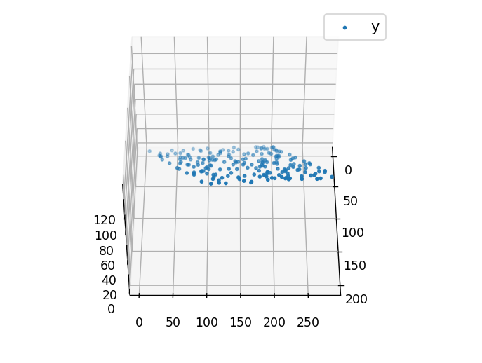

Result :

Regression visualization was demonstrated and executed successfully, showcasing the relationship between the input features and the predicted output in a 3D space.

Program 3

Perceptron with and without bias using UCI Repository

Aim :

To demonstrate the implementation of a Perceptron classifier with and without bias using the UCI Repository.

Algorithm :

STEP - 1 : Load dataset from UCI repository.

STEP - 2 : Preprocess data by separating features and labels.

STEP - 3 : Split the dataset into training and testing sets.

STEP - 4 : Standardize the features.

STEP - 5 : Train the Perceptron classifier without bias.

STEP - 6 : Evaluate the classifier without bias.

STEP - 7 : Train the Perceptron classifier with bias.

STEP - 8 : Evaluate the classifier with bias.

Program :

import numpy as np

import pandas as pd

from sklearn.model_selection import train_test_split

from sklearn.preprocessing import StandardScaler

from sklearn.linear_model import Perceptron

from sklearn.metrics import accuracy_score

# Step 1: Load the dataset

url = "https://archive.ics.uci.edu/ml/machine-learning-databases/iris/iris.data"

# Replace the URL with the actual URL of the dataset from the UCI repository

column_names = ['sepal_length', 'sepal_width', 'petal_length', 'petal_width', 'class']

df = pd.read_csv(url, names=column_names)

# Step 2: Preprocess the data

X = df.drop('class', axis=1)

y = df['class']

# Step 3: Split the data into training and testing sets

X_train, X_test, y_train, y_test = train_test_split(X, y, test_size=0.2, random_state=42)

# Step 4: Standardize the features

scaler = StandardScaler()

X_train_scaled = scaler.fit_transform(X_train)

X_test_scaled = scaler.transform(X_test)

# Step 5: Train the Perceptron classifier without bias

perceptron_without_bias = Perceptron(max_iter=1000, tol=1e-3, eta0=0.1, fit_intercept=False)

perceptron_without_bias.fit(X_train_scaled, y_train)

# Step 6: Evaluate the classifier without bias

y_pred_without_bias = perceptron_without_bias.predict(X_test_scaled)

accuracy_without_bias = accuracy_score(y_test, y_pred_without_bias)

print("Accuracy without bias:", accuracy_without_bias)

# Step 7: Train the Perceptron classifier with bias

perceptron_with_bias = Perceptron(max_iter=1000, tol=1e-3, eta0=0.1, fit_intercept=True)

perceptron_with_bias.fit(X_train_scaled, y_train)

# Step 8: Evaluate the classifier with bias

y_pred_with_bias = perceptron_with_bias.predict(X_test_scaled)

accuracy_with_bias = accuracy_score(y_test, y_pred_with_bias)

print("Accuracy with bias:", accuracy_with_bias)

Output :



Result :

The Perceptron classifier, both with and without bias, was demonstrated and executed successfully on the Iris dataset.

Program 4

Case study on ontology where ethics is at stake

Title: Ethical Dilemmas in Ontology Development: A Case Study

Introduction:

Ontology, the study of existence and the nature of reality, plays a crucial role in various domains, including information science, artificial intelligence, and knowledge representation. However, the development and application of ontology systems can give rise to ethical challenges that require careful consideration. This case study explores a scenario where ethics are at stake in the development of an ontology system.

Case Scenario:

Imagine a team of researchers working on a project to create an ontology for autonomous vehicles. The goal is to develop a comprehensive understanding of the environment, traffic rules, and potential hazards to enhance the decision-making capabilities of self-driving cars. However, the team encounters a significant ethical dilemma in the process.

Ethical Concern:

The researchers realize that to accurately capture the complexities of real-world driving scenarios, the ontology needs to include data related to human behavior in various situations, including potential rule violations and dangerous driving practices. This raises ethical concerns about the collection and utilization of data that might compromise individuals' privacy and potentially infringe upon ethical standards.

Key Ethical Considerations:

* Privacy Invasion: The inclusion of detailed information about specific individuals' driving behaviors may infringe upon privacy rights. How should the team balance the need for realistic data with the ethical imperative to protect individuals' privacy?
* Bias and Discrimination: The collected data might inadvertently introduce biases or reinforce existing societal prejudices. How can the researchers ensure that the ontology does not perpetuate discrimination based on factors such as race, gender, or socioeconomic status?

Resolution Strategies:

* Privacy by Design: Implementing privacy-preserving measures from the outset, such as anonymizing data and using encryption techniques, to minimize the risk of privacy violations.
* Public Engagement: Engaging the public in discussions about the ethical implications of the ontology, gathering input, and incorporating public perspectives into decision-making.

Conclusion:

This case study highlights the intricate ethical considerations that can emerge in ontology development, especially when dealing with real-world data. Striking a balance between advancing technology and respecting ethical principles is crucial to ensure the responsible and ethical application of ontologies in various domains.

Program 5

Regression model without a bias and with bias

Aim :

To generate random data with a linear regression models with and without bias using

scikit-learn.

Algorithm :

STEP - 1 : Import necessary libraries: import numpy as np, from sklearn.linear_model import LinearRegression, import matplotlib.pyplot as plt.

STEP - 2 : Set a random seed for reproducibility: np.random.seed(42).

STEP - 3 : Generate random data: X as 100 random points, and y as a linear function of X with added random noise.

STEP - 4 : Create a linear regression model without bias: model_without_bias = LinearRegression(fit_intercept=False).

STEP - 5 : Fit the model without bias to the data: model_without_bias.fit(X, y).

STEP - 6 : Create a linear regression model with bias: model_with_bias = LinearRegression(fit_intercept=True).

STEP - 7 : Fit the model with bias to the data: model_with_bias.fit(X, y).

Program :

import numpy as np

from sklearn.linear_model import LinearRegression

import matplotlib.pyplot as plt

# Generate some random data

np.random.seed(42)

X = 2 * np.random.rand(100, 1)

y = 4 + 3 * X + np.random.randn(100, 1)

# Linear regression without bias

model_without_bias = LinearRegression(fit_intercept=False)

model_without_bias.fit(X, y)

# Linear regression with bias

model_with_bias = LinearRegression(fit_intercept=True)

model_with_bias.fit(X, y)

# Plot the data and regression lines

plt.scatter(X, y, label='Data')

plt.plot(X, model_without_bias.predict(X), label='Without Bias', color='red')

plt.plot(X, model_with_bias.predict(X), label='With Bias', color='green')

plt.xlabel('X')

plt.ylabel('y')

plt.legend()

plt.show()

Output :

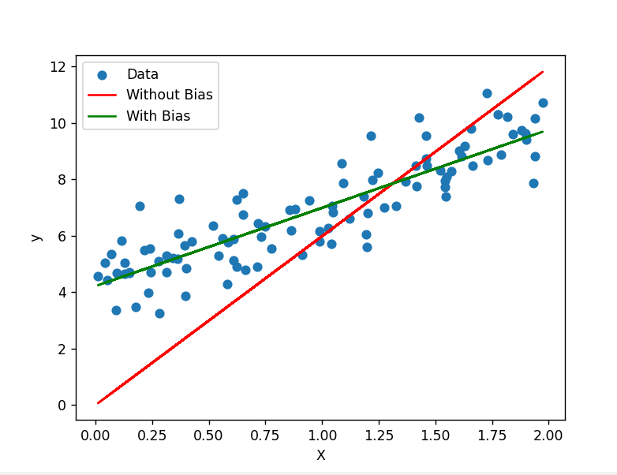

Result :

Linear regression models with and without bias using scikit-learn was demonstrated and executed successfully.

Program 6

Case study of ethical initiatives in healthcare

Title: Implementing Ethical Guidelines for Patient Care at St. Mercy Hospital

Introduction:

St. Mercy Hospital, a large urban healthcare facility, recognized the importance of maintaining ethical standards in patient care. In response to the growing concerns about ethical dilemmas in healthcare, the hospital decided to implement a series of initiatives to ensure ethical conduct and enhance the overall patient experience.

Case Scenario:

Ms. Johnson, a 75-year-old patient with multiple chronic conditions, has been admitted to St. Mercy Hospital. During her stay, her family expresses concerns about aggressive treatment options, emphasizing the importance of maintaining her comfort and dignity. The healthcare team is faced with a challenging decision regarding the appropriate course of action.

Ethical Guidelines:

1. Patient Autonomy :

* Respect the right of patients to make informed decisions about their care.
* Ensure open communication with patients and their families, providing them with the necessary information to make informed choices.

1. Beneficence and Non-Maleficence :

* Strive to benefit the patient and prevent harm.
* Prioritize patient safety and well-being in all medical decisions and interventions.

1. Justice :

* Treat all patients with fairness and equity, irrespective of their background, socioeconomic status, or other factors.
* Allocate resources fairly, considering the needs of all patients.

1. Privacy and Confidentiality :

* Safeguard patient information and ensure confidentiality.
* Obtain informed consent before disclosing patient information, unless required by law.

Implementation Plan:

To integrate these ethical guidelines into daily practice, St. Mercy Hospital will:

* Conduct regular training sessions for healthcare professionals on ethical decision-making.
* Establish an Ethics Committee to review complex cases and provide guidance.
* Periodically assess and update the guidelines to align with evolving ethical standards.

Conclusion:

By implementing and adhering to these ethical guidelines, St. Mercy Hospital is dedicated to providing patient-centered care that respects autonomy, promotes beneficence, upholds justice, and maintains the trust of the community. Through these efforts, the hospital aims to create an environment where ethical considerations are an integral part of the healthcare delivery process.

Program 7

Case study of ethical initiatives in autonomous vehicles

Title: Ethical Initiatives in Autonomous Vehicles: A Case Study

Introduction:

Autonomous vehicles (AVs) have emerged as a transformative technology in the transportation sector, promising increased safety, efficiency, and convenience. This case study explores the ethical initiatives implemented by a leading autonomous vehicle company, AutoSafe, to address these concerns and foster responsible innovation.

Company Background:

AutoSafe is a fictitious company at the forefront of autonomous vehicle development. With a commitment to ethical practices, AutoSafe aims to redefine the future of transportation by integrating cutting-edge technology with a strong emphasis on safety and ethical considerations.

Key Ethical Initiatives:

1. Safety First Approach:

AutoSafe prioritizes safety as a fundamental principle in AV development. The company invests extensively in rigorous testing, simulations, and real-world scenarios to ensure the highest safety standards. By collaborating with regulatory bodies, industry experts, and research institutions, AutoSafe actively participates in defining safety benchmarks and continuously improves its AV systems.

2. Transparent Decision-Making Algorithms:

To address concerns related to the decision-making algorithms of autonomous vehicles, AutoSafe adopts a transparent approach. The company provides detailed documentation on how its algorithms function, including how they prioritize different ethical considerations in complex scenarios.

3. Ethical AI and Machine Learning:

AutoSafe is committed to ethical AI and machine learning practices. The company actively avoids biased training data and continually assesses and mitigates any unintended consequences of its algorithms.

4. Public Awareness and Education:

Recognizing the importance of public understanding and acceptance of autonomous vehicles, AutoSafe engages in comprehensive public awareness campaigns. These initiatives aim to educate the public about the benefits of AVs, address concerns related to safety and ethics, and create an open dialogue to gather feedback from the community.

Conclusion:

By prioritizing safety, transparency, ethical AI, public awareness, privacy protection, and continuous collaboration, AutoSafe sets a benchmark for the ethical development of autonomous vehicles, contributing to the establishment of industry-wide standards and guidelines.

Program 8

Case study of ethical initiatives in defense

Title: Title: Ethical Initiatives on Responsible Military Technology

Introduction:

In the rapidly evolving landscape of military technology, ethical considerations are crucial to ensure responsible development and deployment. This case study explores an imaginary scenario involving a defense contractor, TechDefend, and their initiative to prioritize ethical considerations in the development of a new military technology.

Company Background:

TechDefend is a leading defense contractor known for its cutting-edge innovations in military technology. Recently, the company embarked on a new project to develop an autonomous drone system with advanced targeting capabilities.

Case Scenario:

TechDefend's ethical initiatives faced a critical test when a government expressed interest in purchasing the autonomous drone system for use in a conflict zone. The government had a history of human rights violations, raising concerns about the misuse of the technology. The Ethics Review Board at TechDefend conducted an in-depth assessment and, in consultation with external experts and stakeholders, decided to withhold the sale unless strict conditions were met. These conditions included compliance with international laws, third-party monitoring of system use, and assurance that the technology would not be deployed in violation of human rights.

Key Ethical Initiatives:

* Ethical Design Principles:

TechDefend established a set of ethical design principles that prioritize transparency, accountability, and adherence to international laws and treaties. These principles guide every stage of the technology development process, from conception to deployment.

* International Collaboration:

Recognizing the global nature of military conflicts, TechDefend collaborated with international partners and regulatory bodies to establish a framework for responsible technology development. This included adherence to existing arms control agreements and the creation of new protocols specific to emerging technologies.

* Robust Privacy Measures:

To address concerns related to privacy, TechDefend incorporated state-of-the-art privacy protection measures into the technology. The autonomous drone system is designed to minimize data collection, ensure data security, and undergo regular privacy impact assessments.

Conclusion:

By prioritizing safety, transparency, ethical AI, public awareness, privacy protection, and continuous collaboration, AutoSafe sets a benchmark for the ethical development of autonomous vehicles, contributing to the establishment of industry-wide standards and guidelines.